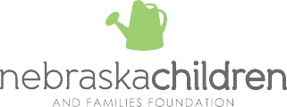

COMMUNITY CENTRAL NAVIGATORS AND COORDINATORS

Community Collaborative | Central Navigator | Coordinator | Bi-lingual (Spanish) Contact | Counties Served
Buffalo County Community Collaborative | Wanda Fedorchik | positivepressure@bcchp.org 308-865-2283 (office) | 308-240-0813 (cell) | Denise Zwiener  308-865-2280 | dzwiener@bcchp.org | Martha Marfileno | wellness@bcchp.org 308-865-2287 (office) | 308-627-4257 (cell) | Buffalo
Community and Family Partnership | Tammy Bichlmeier (Platte County) 402-366-5615 | pccentralnav@gmail.com | Sarah Papa  308-991-0030 | Sarah.cfpartnership@gmail.com | 833-383-0280 | Boone, Colfax, Nance, Platte
Dawson County Community Collaborative | Pam Reicks (Cozad)  308-784-2804 | cfcozad@cozadtel.net  Nichole Hetz (Gothenburg)  308-529-8784 | GECLC.coordinator@gmail.com  Rocio Pastor (Lexington)  308-746-3685 | lexnav1dcfp@gmail.com | Nichole Hetz  308-529-8784 | geclc.coordinator@gmail.com | Rocio Pastor (Lexington)  308-746-3685 | lexnav1dcfp@gmail.com | Dawson
Douglas County Community Response Collaborative | Nikia Gunn-Abdulai  531-301-3021 | ngunn-abdulai@nebraskaearly.org | Deborah Dancer  402-595-1326 x.2003 | ddancer@projectharmony.com | 833-383-0280 | Douglas
Families 1st Partnership | Tori Courter  308-520-3743 | info@families1stpartnership.org | Caroline Sabin  308-520-0608 | caroline@families1stpartnership.org | Margot Dainowski  308-221-0536 | margot.dainowski@nebraska.gov | Lincoln
Fremont Family Coalition | Shelby Rice  402-721-4157 | shelby@fremontunitedway.org  Rosanna Jaeger  402-721-4157 |rossana@fremontunitedway.org  Jacki Trujilo  402-721-4157 | jacki@fremontunitedway.org | Steph Gardeman  402-721-4157 | steph@fremontfamilycoalition.org | 833-383-0280 | Burt, Dodge, Washington
Four Counties Collaborative | Vacant | Laura Osborn  402-274-7510 | FourCountyDiversion@gmail.com | 833-383-0280 | Johnson, Nemaha, Pawnee, Richardson
Growing Community Connections | Sandy Nation  402-494-3337 ext. 22 | snation@siouxlandship.org | JoAnn Gieselman  712-222-6383 | jgieselman@siouxlandship.org | 833-383-0280 | Dakota
Hall County Community Collaborative (H3C) | Valerie Roth  308-930-9046 | h3cnavigator@gmail.com | Julie Nash  308-930-9038 | h3cdirector@gmail.com | 308-380-0651 | Franklin, Hall, Hamilton, Harlan, Howard, Kearney, Merrick, Phelps
Lift Up Sarpy | Carmen Bradley  402-292-2961 | cbradley@encapomaha.org | Tanya Gifford  402-306-3749 | tgifford@liftupsarpycounty.org | Sandy Diaz | Sarpy
Lancaster County Coalition | Sam Gross (she, her)  402-875-9388 | sgross@communityactionatwork.org | Rachael Surmick  402-441-7774 | rsurmick@unitedwaylincoln.org | 833-383-0280 | Lancaster
Norfolk Family Coalition | Jamie Bouslaugh  402-640-2409 | centralnavigator@norfolkfamilycoalition.org | Britney Watson  402-640-2409 | britschweitzer@gmail.com | 833-383-0280 | Madison, Pierce, Stanton, Wayne
Panhandle Partnership | Carmen Trevino  308-633-3236 | ctrevino@capwn.org | Faith Mills  308-262-5940 | faith.mills@panhandlepartnership.org | Community Action Partnership of Western Nebraska 308-635-3089 | Banner, Box Butte, Cheyenne, Dawes, Deuel, Garden, Kimball, Morrill, Scottsbluff, Sheridan, Sioux
Better Together/ Partners 4 Otoe County | Vanessa Sherman  402-969-0319 | vsherman@otoecountyne.gov | Lisa Chaney  402-713-5270 | partners4oc@gmail.com | 833-383-0280 | Otoe
Project Everlast Lincoln at The HUB | Lindsay Drake  402-580-9247 | ldrake@hublincoln.org |  | 833-383-0280 | Lancaster
Project Everlast Omaha | Brittney Livingston  402-875-3594 | blivingston@nebraskachildren.org |  | Aaron Weaver  402-875-3594 | aweaver@nebraskachildren.org | Douglas, Sarpy
Sandhills Community Collaborative | D Boutwell  308-212-2488 | dboutwell@central-plains.org | Cathy Minnick  308-870-3180 | cminnick@central-plains.org | Monica Guido  308-870-2134 | mguidolopez@gmail.com | Blaine, Custer, Garfield, Greeley, Loup, Sherman, Valley, Wheeler
Community Impact Network of Adams, Clay, Webster, Nuckolls | Chandra Essex  402-461-8418 | navigator@unitedwayscne.org | Brady Rhodes  402-461-8418 | coordinator@unitedwayscne.org | 833-383-0280 | Adams, Clay, Nuckolls, Webster
Southeast Nebraska Collaborative | Collena Laschanzky  402-729-6510 | claschanzky@bvca.net | Collena Laschanzky  402-729-6510 | claschanzky@bvca.net | 833-383-0280 | Butler, Cass, Fillmore, Gage, Jefferson, Otoe, Polk, Saline, Seward, Thayer, York
Valentine Children and Families Coalition | Vacant | Sonia Coats  402-252-9030 | valentinecfc@gmail.com | 833-383-0280 | Cherry
York County Health Coalition | Vacant  402-745-6604 | yorkcommunityresponse@gmail.com | Jake Owens ychcjake@gmail.com | 833-383-0280 | York
Tribal Community Response
Omaha Tribe of Nebraska | Joseph Fleming  402-837-5331 | joseph.fleming@nebraska.gov |  | 833-383-0280 | Omaha Tribe of Nebraska
Panhandle | Rebekah Barber | bekahb6@hotmail.com and bbarber@societyofcare.org  Edison Red Nest III | erednest@societyofcare.org |  | 833-383-0280 | Panhandle/Western NE Native American outreach
Santee-Sioux Nation | Carrie Rouillard  402-857-2300 | crouillard@societyofcare.org | Yvonne Bickerstaff  402-857-2300 | ybickerstaff@societyofcare.org | 833-383-0280 | Santee-Sioux Tribe of Nebraska
Winnebago Tribe of Nebraska | Angie Walker  402-878-2379 | angie.walker@winnebagotribe.com |  | 833-383-0280 | Winnebago Tribe of Nebraska

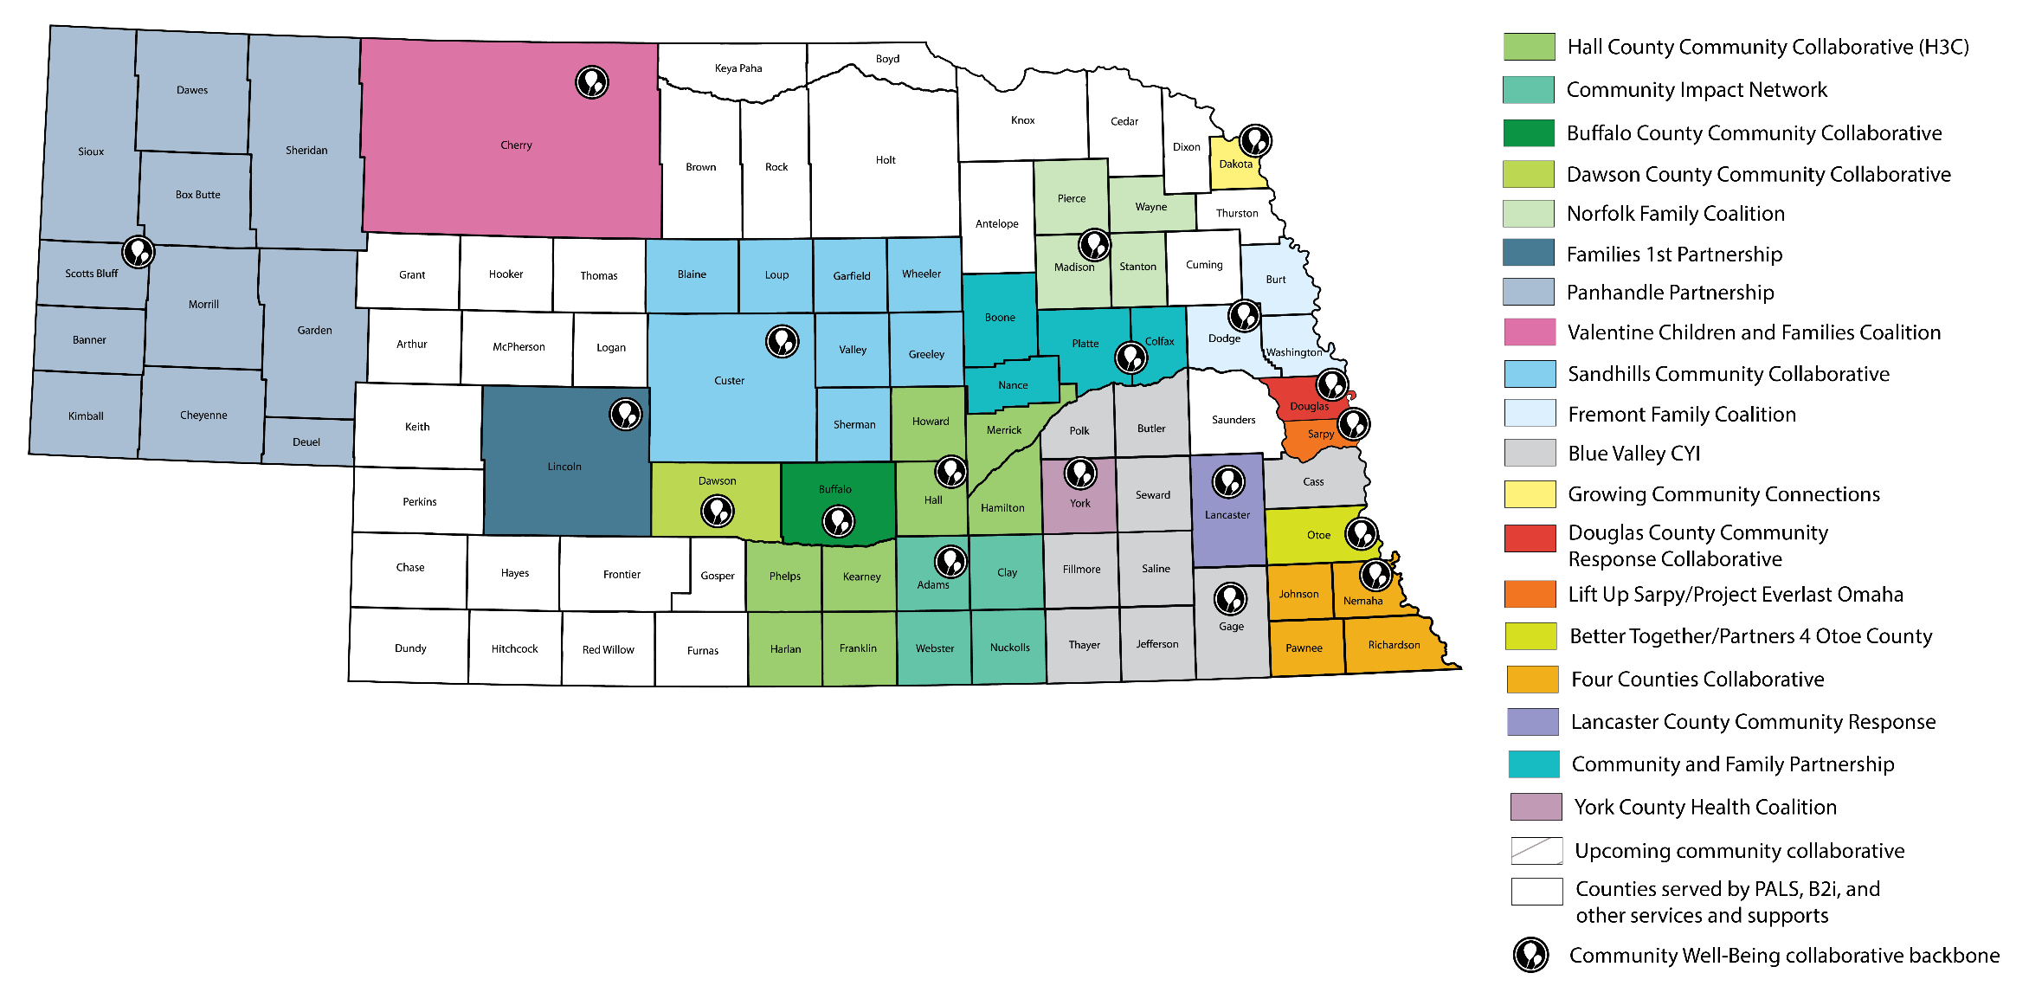
WHAT ARE COMMUNITY COLLABORATIVES?
Communities bring all of the important players to the collaboration—nonprofits, teachers, doctors and nurses, law enforcement, businesses, government agencies, and most importantly, parents and youth. Local communities identify the missing pieces in services, develop long-term plans using the latest strategies and data, and work together. The community collaboration then agrees on common goals, measurements, and tasks—working together to make their community strong. To connect to
your local collaborative, please contact the Coordinator in your area.

WHAT IS CENTRAL NAVIGATION?
Central Navigation is a single point of contact for children, youth, and families in Nebraska when they need help. Families can voluntarily choose to work with Central Navigation. They will work with one Navigator who will be able to connect them with many different sources of assistance. To get help, please contact the Central Navigator in your area.

